LA SIRÈNE US

LOS ANGELES MARKET BUSINESS PLAN

1. Executive Summary
La Sirène proposes to establish a luxury garment care service in the Los Angeles area, targeting one of the world’s most valuable luxury markets. Building upon the proven success of Paris and London, the LA model integrates:
- A Beverly Hills intake Boutique directly connected to the CHANEL client ecosystem and located within the prestigious Rodeo Drive district.
- A nearby Workshop equipped for eco responsible cleaning, care, and restoration
- A ‘Hub and Spoke’ distribution model leveraging the workshop and boutique as central hubs, supported by the following pickup and drop off points:
  - Selected partners (luxury residences, hotels, private members clubs, private jet airport lounges, etc.)
  - Client’s homes
  - B2B clients (Brands’ After Sales services or Showroom, secondhand retailer, etc.)
The model is powered by a dedicated electric fleet, ensuring a reactive, eco friendly and efficient flow of goods.
- A dedicated app (the ‘Digital Vault’) that unifies intake, workflow management, client profiles, and wardrobe archiving
This model positions La Sirène as a significant contributor to circular fashion, promoting garment longevity along with client experience innovation, while building a scalable, profitable business capturing unmet local demand.
Target launch: QX 2027 | Break even target: Y5 post launch | Year 1 revenue target: $ 500K | Year 5 revenue target: $ 2.4M

2. The Los Angeles Market Opportunity
Los Angeles represents one of the largest global luxury consumption hubs, with client profiles that strongly align with La Sirène’s value proposition.

2.1 Unmet Luxury Cleaning Demand
Clients frequently report they “do not trust” available dry cleaning options with delicate or high end garments. Sales advisors, after sales teams, and boutique directors regularly express the inability to recommend a truly luxury grade cleaner, representing a major client experience gap.

2.2 High Concentration of Affluent Clients
Beverly Hills, Bel Air, Brentwood, Pacific Palisades, Malibu, and West Hollywood concentrate thousands of UHNWIs with extensive luxury wardrobes.
Many of these clients rely heavily on:
- Personal assistants
- Concierge services
- At home pickup and delivery
Within 30 min drive of the Beverly hills intake boutique, we capture 38% of the total LA area Chanel Fashion business, 52% of the RTW business.
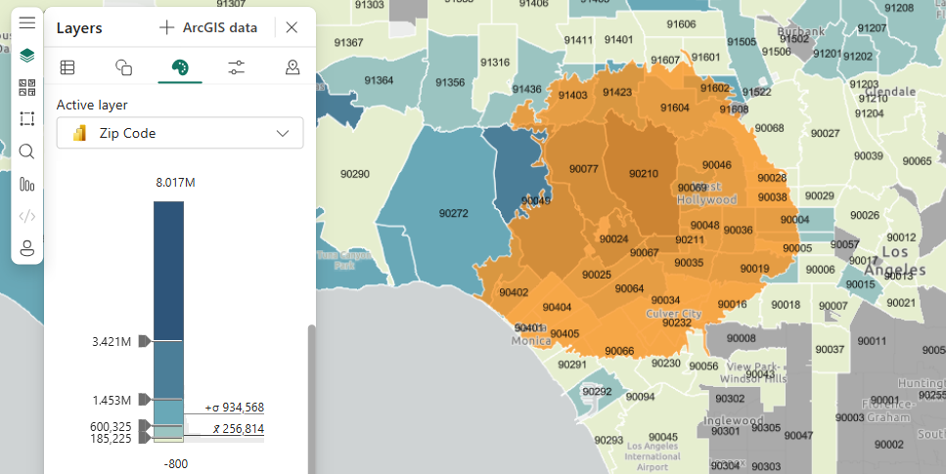
Legend : in orange, the area covered by a 30min drive from the Beverly hills boutique
In blue, the level of 2025 CHANEL Fashion sales by zip codes
The search for a nearby workshop will aim at capturing most of the remaining clients under 30 min drive.

2.3 Growth of Eco Responsible Lifestyles
California leads the U.S. in environmental standards and conscious luxury consumption. La Sirène’s CO₂ and Aquaclean technologies respond to this market, offering:
- Chemical free processes
- Reduced waste
- High garment longevity

2.4 Competitive White Space
The existing market includes:
- A few premium cleaners that are limited in scope and consistency
- Eco cleaners that do not meet luxury standards
- No service that unifies expert craftsmanship + sustainability + luxury experience
This positions La Sirène to capture first mover advantage and anchor a new category: “The Spa for your clothes.”

3. Our Clients

3.1 Individual Clients (B2C) – 60%
Based on Paris and London patterns, we anticipate three major segments:
B2C Segment | Share of Revenue | Profile
CHANEL clients | 25–35% | Frequent purchasers with significant RTW wardrobes requiring expert care.
High net worth local Beverly hills clientele | 40–50% | Luxury consumers in proximity to Beverly Hills. Expect at home service, fast turnaround, flawless finishing
Natural / organic traffic | 20–30% | Fashion forward clients discovering the service through partner buildings, or word of mouth

3.2 Business Clients (B2B) – 40%
La Sirène will serve select professional clients needing high precision garment care:
B2B Segment | Use Case
Stylists & costume departments | Cleaning and care for editorial shoots, red carpet events, film/TV productions
Cinema & entertainment industry | On set wardrobe care, archive preservation for studios
PR agencies & showrooms | Closet maintenance, seasonal garment refresh
Luxury hotels | Garment services for top tier guests (Beverly Wilshire, Hotel Bel Air, etc.)
Private aviation partners | VIP passenger garment services (Van Nuys airport)
Private members clubs | Garment services for members (San Vincente Bungalows, Soho House, etc.)
Retail partners | Maintenance for display, archive, and sample pieces
Resale platforms | Pre sale garment restoration (The RealReal, What Goes Around Comes Around, Recess LA, etc.)

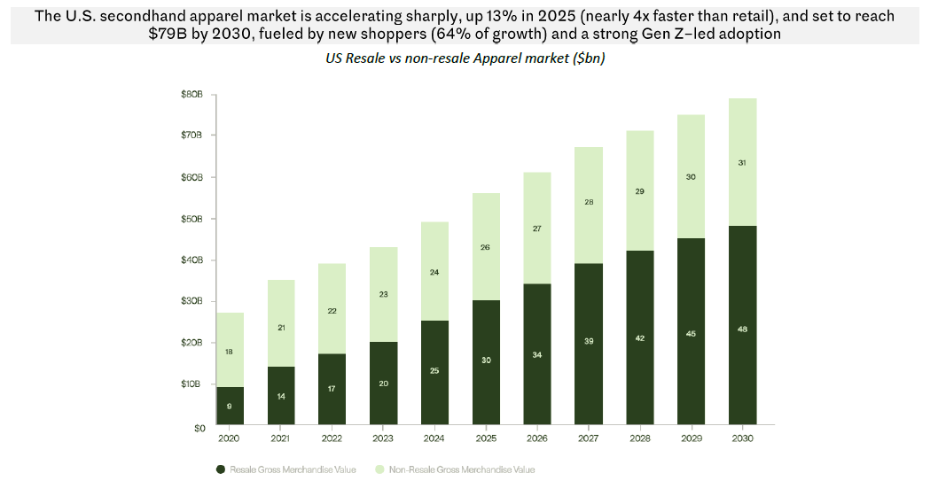

4. Client Reach & Acquisition Strategy

4.1 Launch Phase — Seeding (Months 1–12)
Channel | Tactics
CHANEL activation | Direct referrals from Beverly Hills boutique teams (CB, NM, Saks).
Residential & hotel partnerships | Onboarding 3–5 residential buildings and 2–3 luxury hotels at launch. Concierge introductions, in lobby signage, welcome kits for new residents/guests.
Retail Industry seeding | Complimentary first orders for top brands to try the service. Build word of mouth in the fashion circuit.

4.2 Growth Phase — Scaling (Months 12–24)
Channel | Tactics
Referral program | Client to client referral incentives (complimentary service credit). Personal assistant & concierge referral program.
Digital presence | Targeted social media (Instagram, curated content around garment care, sustainability, wardrobe curation). SEO/local search optimization for “luxury dry cleaning Beverly Hills.”
Strategic PR & editorial | Placement in LA centric luxury media. Sustainability angle press in broader outlets.
B2B pipeline development | Dedicated account manager for entertainment, hotel, and resale platform relationships.
App driven retention | Push notifications for seasonal care reminders. Digital Vault engagement features to increase return visits.

5. Operational Infrastructure
The LA model is built on flexibility, scalability, and high-level execution.

5.1 Beverly Hills Intake Boutique
The boutique is the public facing touchpoint delivering:
- Client greeting and garment diagnostic
- Quotation and intake process
- Express and concierge pickups
- A minimal but refined footprint to control operational costs
Location advantages:
- Proximity to CHANEL Beverly Hills boutiques
- High visibility, conveys trust through a well established luxury presence
- Centrality for first mile logistics in the Beverly Hills neighborhood
Boutique specifications (Year 1):
Parameter | Target
Surface area | 55 m² / 600 sq ft
Daily intake capacity | 80 garments/day
Operating hours | 11am-7pm Tue-Sat
Staffing | 1 FTEs

5.2 The LA Workshop
A dedicated workshop located near the boutique and main partner locations.
Equipment & capabilities:
- CO₂ cleaning equipment
- Aquaclean machines
- Stain removal, ironing, and finishing stations
- Sustainable packaging, storage, and preparation areas
Workshop specifications (Year 1):
Parameter | Target
Surface area | 150 m² / 1500 sq ft
Daily processing capacity | 40+ garments/day
Operating hours | 9am-5pm
Staffing (artisans + support) | 4 FTEs

5.3 Hub and Spoke Pickup & Drop off Model
To match LA lifestyles, the model includes:
- Residential building partnerships (e.g., Beverly West, Sierra Towers, Four Seasons Residences) with private drop off boxes or concierge handling
- Luxury hotel hubs (e.g., Beverly Wilshire, Hotel Bel Air) to serve travelers and couture clients
- Private membership clubs
- Private jet terminal lounges
- Dedicated delivery service using eco friendly vehicles enabling same day or 48 hour turnaround
Delivery fleet (Year 1):
Parameter | Target
Vehicles | 1
Vehicle type | Electric (brand/model TBD)
Service radius | 10 miles from boutique
Delivery route | Daily boutique to workshop trip + workshop to drop off partner locations. Client pick up and deliveries.

6. The App — A Unified Digital Ecosystem
The La Sirène app is the backbone of the business, connecting all client touchpoints.

6.1 Client Features
- Appointment booking and live order tracking
- Pre intake + instant quotation (AI enabled TBC)
- Digital Wardrobe (“The Wardrobe Vault”): each treated item is archived with photos, treatment history, and care recommendations
- Membership and subscription modules (future revenue stream)
  - The membership program is structured in tiers, with each tier providing distinct service offerings such as complimentary delivery, weekly pick-up and drop-off, annual closet audits, and specialized services including art of closet consultations.
- External Storage management (future service)

6.2 Operational Features
- Intake flow digitization for boutique staff
- Workshop workflow management (stain removal, cleaning, finishing stages)
- Courier routing optimization

6.3 Strategic Value (long term – connection with CHANEL)
The Digital Wardrobe positions Chanel for future services such as repairs, alterations, and couture lifecycle management. It transforms garment care into a long term client relationship platform, creating a persistent digital thread between the client, their wardrobe, and CHANEL.

7. Financial Plan & Key Metrics

7.1 Revenue Model
Revenue Stream | Description | Pricing Approach
Garment care (B2C) | Cleaning, pressing, stain removal, restoration for individual clients | Per item pricing; premium tier for couture/delicate
Garment care (B2B) | Volume contracts with hotels, studios, stylists, resale platforms | Potential volume discounts
Concierge delivery | Pick up and delivery fees (or bundled into premium pricing) | Per trip or subscription based
Membership / subscription (future) | Monthly plans for regular clients (e.g., X items/month) | Tiered monthly plans
Restoration & alteration (future) | Advanced garment repair, refit, and archival services | Per item quote

7.2 Revenue Projections
 | Y1 |  | Y2 |  | Y3 |  | Y4 |  | Y5
Net Sales k$ (% vs LY) | 500 |  | 900 | +80% | 1,440 | +60% | 2,016 | +40% | 2,419 | +20%
Units (% vs LY) | 6,011 |  | 9,835 | +64% | 14,987 | +52% | 19,983 | +33% | 22,838 | +14%
Av price $ (% vs LY) | 83 |  | 92 | +10% | 96 | +5% | 101 | +5% | 106 | +5%
Promotion​ | 35 | 7% | 63 | 7% | 101 | 7% | 141 | 7% | 169 | 7%
Consumables | 25 | 5% | 45 | 5% | 72 | 5% | 100.8 | 5% | 121 | 5%
Marketing | 10 | 2% | 18 | 2% | 29 | 2% | 40 | 2% | 48 | 2%
​
Boutique Expenses​ | 1,168 | 234% | 1,368 | 152% | 1,735 | 121% | 1,904 | 94% | 2,070 | 86%
Staff Costs​ | 500 | 100% | 667 | 74% | 974 | 68% | 1,092 | 54% | 1,216 | 50%
Rent​ | 258 | 52% | 259 | 29% | 261 | 18% | 262 | 13% | 264 | 11%
D&A (build)​ | 136 | 27% | 136 | 15% | 136 | 9% | 136 | 7% | 136 | 6%
D&A (equipment)​ | 79 | 16% | 79 | 9% | 81 | 6% | 81 | 4% | 81 | 3%
Transport​ | 50 | 10% | 72 | 8% | 101 | 7% | 121 | 6% | 121 | 5%
External expertise | 50 | 10% | 63 | 7% | 72 | 5% | 81 | 4% | 97 | 4%
IT​ | 20 | 4% | 27 | 3% | 29 | 2% | 20 | 1% | 24 | 1%
Training​ | 25 | 5% | 5 | 1% | 5 | 0% | 5 | 0% | 5 | 0%
Communications​ | 15 | 3% | 18 | 2% | 14 | 1% | 20 | 1% | 24 | 1%
Credit Card Fees​ | 15 | 3% | 27 | 3% | 43 | 3% | 60 | 3% | 73 | 3%
T&E​ | 15 | 3% | 5 | 1% | 5 | 0% | 5 | 0% | 5 | 0%
Property taxes​ | 5 | 1% | 9 | 1% | 14 | 1% | 20 | 1% | 24 | 1%
Other | 25 | 5% | 45 | 5% | 72 | 5% | 101 | 5% | 121 | 5%
​
Operating Profit​ | (703) | -141% | (531) | -59% | (396) | -28% | (29) | -1% | 180 | 7%
Main assumptions to add

8. Team & Organization

8.1 Organizational Structure
Role | # FTEs | Reporting To
Operation Manager | 0.5 | Project Lead – La Sirene US
Flow Manager | 0.5 | Same person as Ops Manager at launch
Assistant Btq Manager | 1 | Operation Manager
Atelier Specialist | 1 | Operation Manager
Alteration and Ironing specialist | 2 | Operation Manager
Delivery Drivers | 1 | External
Total FTEs at launch | 5

8.2 Key Hiring Priorities
- Atelier Specialist: Must have deep expertise in luxury fabric care and couture finishing. Ideally trained in luxury hotel/palace.
- Operations Manager: Strong operational and client relationship background in luxury services. LA market knowledge essential.
- Assistant Btq Manager: CHANEL grade hospitality. Bilingual preferred (English/Spanish; English/Mandarin a plus given LA demographics).

8.3 Training & Knowledge Transfer
- 2 weeks immersion at Paris and/or London workshops for key hires
- Ongoing quality assurance protocols aligned with La Sirène global standards
- Regular cross market knowledge sharing (techniques, client insights, operational best practices)

9. Implementation Timeline
Cf PPT appendix

10. Risks & Mitigations
Risk | Likelihood | Impact | Mitigation
Commercial space usage for Workshop | Medium | High | Landlord reluctance to rent to a ‘dry cleaning’ business.
Demand ramp slower than projected | Medium | High | Conservative staffing plan. Phased spoke rollout. Strong CHANEL client seeding to ensure baseline volume.
Talent scarcity (luxury artisans in LA) | High | High | Cross train from Paris/London. Partner with local textile schools. Competitive compensation.
Regulatory / environmental compliance | Medium | Medium | Early engagement with CA regulators on CO₂ equipment. Ensure all permits secured pre launch.
Real estate cost pressure | Medium | Medium | Boutique designed for minimal footprint. Workshop located in adjacent, lower cost area.
App development | Medium | Medium | MVP first approach. Core features only at launch. Iterative development post launch.

11. Strategic Benefits

Reinforces CHANEL’s sustainability leadership
La Sirène embodies CHANEL’s commitment to garment longevity, responsible care, and reduction of chemical processes.

Deepens client loyalty and increases retention
Clients who entrust their wardrobes to La Sirène return more frequently to CHANEL and view the brand as their holistic fashion partner.

Enables circular economy opportunities
Archiving garments enables future pathways: restoration, after sales services, resale partnerships, and heritage programs.

Creates operational synergy with Chanel boutiques
Boutique teams gain a reliable, brand aligned solution to client care, improving satisfaction and supporting RTW sell through.

Scalable U.S. model
LA becomes the flagship U.S. pilot. Once proven, the model can extend to NYC, Miami, and key CHANEL U.S. markets.

